Electrical Vehicle Performance & Market Analysis:
An Interactive Tableau Dashboard for Business Intelligence
Team ID:
Team Members: Marpina Koteswara Rao

PROJECT FINAL REPORT
Date: 15 July 2026

1. INTRODUCTION

Project Overview
- The rapid growth of electric vehicles (EVs) has transformed the global automotive industry by promoting sustainable transportation and reducing carbon emissions. As the number of EV models continues to increase, consumers and industry professionals require effective tools to compare vehicle performance, pricing, charging capabilities, and driving range. An interactive data visualization dashboard helps simplify complex datasets and enables users to gain meaningful insights for informed decision-making.
- This project, Electrical Vehicle Performance & Market Analysis Dashboard, is developed using MySQL for data preprocessing and Tableau Public for interactive visualization. The dataset contains information about electric vehicle models, including brand, model, body style, top speed, acceleration, driving range, efficiency, charging speed, seating capacity, and prices in different countries.
- The project focuses on transforming raw data into a clean and structured format through SQL operations such as handling missing values, removing unnecessary symbols, converting text values into numeric values, and creating calculated fields. The processed data is then visualized in Tableau using multiple interactive charts, filters, and dashboards to analyze EV performance from different perspectives.
- The dashboard provides valuable insights into vehicle performance, regional charging infrastructure, price comparison, and body-style distribution. It enables users to compare different EV brands and models, identify high-performance vehicles, analyze pricing trends, and understand market characteristics through intuitive visualizations.
- The project demonstrates the practical application of data cleaning, data transformation, SQL querying, and business intelligence techniques to solve real-world analytical problems while improving decision-making through interactive dashboards.

2. IDEATION PHASE
2.1 Problem Statement
Electric vehicle information is often available across multiple sources in raw and inconsistent formats, making it difficult to compare vehicle specifications and market trends effectively. Important attributes such as top speed, driving range, charging speed, acceleration, and pricing are represented using different units and formats, limiting meaningful analysis.There is a need for an interactive analytical dashboard that cleans, organizes, and visualizes EV data, enabling users to compare vehicle performance, identify market trends, and make informed decisions based on accurate insights.

2.2 Empathy Map Canvas
2.1 Empathy Map
The empathy mapping exercise was conducted to better understand the expectations of users who want to analyze electric vehicle performance and market trends. The focus was on identifying the information users need, the challenges they face while comparing EVs, and how an interactive dashboard can simplify data-driven decision-making.
Think & Feel
- Which electric vehicle offers the best overall performance?
- Which EV provides the highest driving range?
- Is the vehicle worth its price?
- Which brand offers the best value for money?
- Which EV charges the fastest?
- Which body style suits my needs?
- Which brand is more reliable?
See
- Different EV models available in the market.
- Vehicle specifications across multiple websites.
- Charging stations distributed across various regions.
- Increasing adoption of electric vehicles.
- Rapid technological advancements in battery performance.
Hear
- EVs are environmentally friendly.
- Charging infrastructure is improving.
- Tesla and other leading brands dominate the market.
- Consumers compare price, range, and charging speed before purchasing.
- Government policies encourage electric vehicle adoption.
Say & Do
- Compare multiple EV brands before buying.
- Check top speed, range, and charging capabilities.
- Analyze price differences between models.
- Search for the best-performing electric vehicle.
- Use dashboards to understand market trends.
Pain Points
- Data is scattered across multiple sources.
- Difficult to compare several vehicle specifications simultaneously.
- Raw datasets contain inconsistent formats.
- Missing values reduce analysis accuracy.
- Limited visualization for decision-making.
Expected Gains
- Interactive comparison of EV models.
- Accurate and clean data.
- Easy identification of top-performing vehicles.
- Better understanding of charging infrastructure.
- Quick insights through visual dashboards.

2.2 Brainstorming

Since this project was completed individually, the brainstorming process involved generating multiple solution ideas independently before selecting the most practical approach.

The following ideas were considered:

EV Brand Performance Analysis

Top Speed Comparison Dashboard

Driving Range Analysis

Charging Infrastructure Analysis

Electric Vehicle Price Comparison

Acceleration Distribution Analysis

Charging Speed Analysis

Interactive Tableau Dashboard

Data Cleaning using MySQL

Story-based Data Presentation

2.3 Individual Idea Listing

As this project was developed independently, all ideas were generated and evaluated individually before selecting the final solution.

The brainstorming focused on identifying analytical features that provide maximum value to users interested in electric vehicle performance and market trends.

2.4 Idea Clustering

The generated ideas were grouped into meaningful categories based on their analytical objectives.
Theme | Ideas Included
Vehicle Performance | Top Speed, Acceleration, Driving Range
Pricing Analysis | Price Comparison, Price Range
Charging Infrastructure | Charging Stations by Region
Dashboard Development | Tableau Dashboard, Story, Interactive Filters
Data Engineering | Data Cleaning, SQL Preprocessing, Calculated Fields

2.5 Idea Prioritization Matrix

Each idea was evaluated based on Importance and Feasibility.

DO FIRST

Data Cleaning & SQL Preprocessing

Interactive Tableau Dashboard

EV Performance Analysis

Driving Range Analysis

Charging Station Distribution

PLAN NEXT

Customer Segmentation based on EV Preferences

Predictive EV Demand Analysis

Battery Health Prediction

FILL-IN TASKS

Story Creation

Dashboard Publishing

Performance Optimization

RECONSIDER

Real-time Vehicle Tracking

Live Charging Station Monitoring

AI-based EV Recommendation System

2.6 Final Selected Idea

After evaluating all possible ideas, the selected solution was Electrical Vehicle Performance & Market Analysis Dashboard.

The project combines SQL-based data preprocessing with Tableau visualization to create an interactive dashboard that enables users to compare electric vehicles based on performance, pricing, driving range, charging speed, acceleration, and charging infrastructure.

The dashboard provides meaningful business insights using multiple interactive visualizations and filters, making EV data easier to understand and analyze.

3. REQUIREMENT ANALYSIS

3. REQUIREMENT ANALYSIS
Requirement analysis is one of the most important phases of project development. It involves identifying the project's objectives, understanding user needs, and defining the functional and non-functional requirements required to develop an effective analytical dashboard.
The primary goal of this project is to transform raw electric vehicle data into meaningful insights using SQL data preprocessing and Tableau visualization techniques. The dashboard is designed to help users compare electric vehicle performance, pricing, driving range, charging infrastructure, and other important specifications.

3.1 Stakeholder Analysis
Since this project was developed individually, the primary stakeholders include users who need insights into electric vehicle performance and market trends.
Stakeholder | Role
Data Analyst | Cleans, preprocesses, analyzes, and visualizes EV data.
EV Buyers | Compare vehicle specifications before purchasing.
Automobile Manufacturers | Analyze competitor vehicle performance.
Researchers | Study EV market trends and charging infrastructure.
Business Analysts | Generate insights from interactive dashboards.

3.2 Functional Requirements
The dashboard should provide the following functionalities:
- Import electric vehicle dataset into MySQL.
- Clean and preprocess raw data.
- Remove duplicate records.
- Handle missing values using appropriate techniques.
- Convert textual data into numerical format.
- Create calculated fields.
- Connect processed data to Tableau.
- Generate interactive visualizations.
- Apply filters for Region, Brand, Model, Body Style, Price Range, and Driving Range.
- Create an interactive dashboard.
- Develop a Tableau Story to explain insights.

3.3 Non-Functional Requirements
The system should satisfy the following quality requirements:
Performance
- Dashboard should load quickly.
- Visualizations should respond instantly to filters.
Reliability
- Display accurate and consistent data.
- Handle missing values correctly.
Usability
- Easy-to-use dashboard layout.
- Clear visualization titles and labels.
- Interactive filtering options.
Maintainability
- Dataset can be updated easily.
- Additional charts can be added without redesigning the dashboard.
Scalability
- Supports larger EV datasets.
- Can integrate future datasets without significant modification.

3.4 User Stories
User Story 1
As an EV buyer, I want to compare different vehicle brands so that I can select the best-performing electric vehicle.

User Story 2
As a business analyst, I want to analyze charging station distribution by region so that I can understand infrastructure availability.

User Story 3
As a researcher, I want to compare driving ranges among EV brands to study battery performance.

User Story 4
As a data analyst, I want to clean and preprocess raw EV data so that accurate visualizations can be generated.

User Story 5
As a user, I want interactive filters to explore different brands, models, and body styles efficiently.

3.5 Requirement Prioritization
Requirement | Priority
Data Cleaning | High
Missing Value Handling | High
Tableau Dashboard | High
Interactive Filters | High
Story Creation | Medium
Dashboard Publishing | Medium
Future Predictive Analytics | Low

3.6 Use Case Description
Actor
User
Use Cases
- Load EV Dataset
- Clean Data
- Handle Missing Values
- Perform SQL Transformations
- Create Calculated Fields
- Connect MySQL to Tableau
- Build Visualizations
- Apply Filters
- View Dashboard
- Explore Tableau Story
- Analyze Business Insights

3.7 Software Requirements
Software | Purpose
MySQL Workbench | Data preprocessing and SQL queries
Tableau Public | Dashboard development
Microsoft Excel | Dataset preparation
Microsoft Word | Documentation
Windows 11 | Operating System

3.8 Hardware Requirements
Hardware | Specification
Processor | Intel Core i5 / AMD Ryzen 5 or higher
RAM | 8 GB or above
Storage | 256 GB SSD or above
Display | 1366 × 768 resolution or higher
Internet | Required for Tableau Public publishing

3.9 Requirement Traceability Matrix
Requirement | Implemented In
Data Cleaning | MySQL
Missing Value Handling | SQL Queries
Data Transformation | SQL Functions
Dashboard Development | Tableau
Interactive Filters | Tableau Dashboard
Story Presentation | Tableau Story
Business Insights | Dashboard Visualizations
4. PROJECT DESIGN
The project design phase focuses on defining the overall system architecture, data flow, technology stack, and workflow for developing the Electrical Vehicle Performance & Market Analysis Dashboard. The design ensures that raw EV datasets are transformed into meaningful business insights through data preprocessing, visualization, and interactive analytics.
The architecture follows a layered approach consisting of data collection, preprocessing, storage, visualization, and presentation. This approach improves data quality, simplifies dashboard development, and enhances user experience.

4.1 Problem–Solution Fit
The Problem–Solution Fit Canvas validates that the proposed solution effectively addresses the challenges faced by users when analyzing electric vehicle data.
Block | Details
1. Customer Segments | EV buyers, Data Analysts, Researchers, Automobile Manufacturers, Business Analysts
2. Jobs-to-be-Done | Compare electric vehicles, analyze pricing, evaluate performance, study charging infrastructure
3. Triggers | Difficulty comparing multiple EV models, inconsistent datasets, lack of interactive analytics
4. Emotions (Before / After) | Before: Confused by scattered data. After: Confident through interactive dashboards and visual insights.
5. Existing Solutions | Excel spreadsheets, static reports, scattered online information
6. Customer Constraints | Inconsistent data, missing values, lack of visualization skills
7. Behaviour | Users frequently compare specifications before purchasing an EV
8. Channels | Tableau Public Dashboard, Reports, Presentations
9. Root Cause | EV data exists in different formats and sources, making comparison difficult
10. Proposed Solution | A centralized SQL-based data preprocessing pipeline with interactive Tableau dashboards and stories for EV performance analysis

4.2 Proposed Solution
The proposed solution integrates multiple electric vehicle datasets into a centralized MySQL database. SQL queries are used to clean and preprocess the data by removing missing values, standardizing formats, converting text into numerical values, and creating calculated fields.
The processed dataset is then connected to Tableau Public, where interactive dashboards and stories are developed to analyze:
- Vehicle Performance
- Top Speed
- Driving Range
- Acceleration
- Charging Infrastructure
- Price Comparison
- Brand-wise Analysis
- Body Style Distribution
The dashboard enables users to interact with the data through filters, drill-down analysis, and visual storytelling.

4.3 Solution Architecture
The solution architecture follows a five-layer design.
Layer 1 – Data Source Layer
- EV Specifications Dataset
- Charging Station Dataset
- EV India Dataset
- Cheapest Electric Cars Dataset
↓
Layer 2 – Data Preparation Layer
- Import CSV files
- SQL Data Cleaning
- Missing Value Handling
- Duplicate Removal
- Data Type Conversion
- Feature Engineering
↓
Layer 3 – Data Storage Layer
- MySQL Database
- Processed EV Tables
- Cleaned Analytical Dataset
↓
Layer 4 – Visualization Layer
- Tableau Public
- Interactive Charts
- KPI Cards
- Dashboard
- Tableau Story
↓
Layer 5 – Presentation Layer
- Dashboard Users
- Data Analysts
- Researchers
- EV Buyers
- Business Decision Makers

4.4 Data Flow Diagram
DFD Level–0
EV Dataset
│
▼
EV Dashboard System
│
▼
End User

DFD Level–1
CSV Files
│
▼
Import into MySQL
│
▼
SQL Data Cleaning
│
▼
Data Transformation
│
▼
Processed Database
│
▼
Tableau Public
│
▼
Dashboard & Story
│
▼
Users

4.5 Technology Stack
Component | Technology Used
Programming Language | SQL
Database | MySQL Workbench 8.0
Data Visualization | Tableau Public
Dataset Format | CSV
Documentation | Microsoft Word
Presentation | Microsoft PowerPoint
Version Control | GitHub
Operating System | Windows 11

4.6 Dashboard Workflow
The dashboard development process consists of the following stages:
- Collect EV datasets.
- Import datasets into MySQL.
- Perform SQL data preprocessing.
- Handle missing values.
- Remove duplicates.
- Convert textual values into numerical values.
- Create calculated fields.
- Connect MySQL with Tableau Public.
- Build individual worksheets.
- Design interactive dashboard.
- Create Tableau Story.
- Publish dashboard and generate insights.

4.7 Database Design
The MySQL database contains cleaned EV information with attributes such as:
- Brand
- Model
- Body Style
- Top Speed
- Range
- Acceleration
- Efficiency
- Fast Charge Speed
- Price in Germany
- Price in UK
- Region
- Charging Station Details
Relationships between multiple datasets are established using common attributes where applicable, ensuring consistent analysis across vehicle specifications and charging infrastructure.

4.8 Dashboard Components
The final Tableau dashboard includes the following visualizations:
- Average Top Speed by Brand and Body Style
- Count of Charging Stations by Region
- Top 10 EV Models by Maximum Top Speed
- Acceleration Distribution by Body Style
- Electric Vehicle Price Comparison
- Average Driving Range by Brand
Interactive filters include:
- Brand
- Body Style
- Region
- Model
- Price
- Driving Range

5. PROJECT PLANNING & SCHEDULING

Project planning is an essential phase that ensures the systematic execution of the Electrical Vehicle Performance & Market Analysis Dashboard. Since this project was developed individually, the planning process involved defining tasks, estimating effort, prioritizing activities, and scheduling development in multiple sprints. This structured approach helped complete data collection, preprocessing, visualization, dashboard development, and documentation within the planned timeline.

5.1 Product Backlog

The product backlog contains all the development tasks identified during the planning phase.
Sprint | Functional Requirement | User Story / Task | Story Points | Priority | Assigned To
Sprint-1 | Data Collection | Collect EV datasets from multiple sources | 2 | High | Koti Marpina
Sprint-1 | Data Cleaning | Handle missing values | 5 | High | Koti Marpina
Sprint-1 | Data Transformation | Convert text fields into numeric values | 3 | High | Koti Marpina
Sprint-1 | Data Integration | Merge multiple EV datasets | 3 | High | Koti Marpina
Sprint-1 | Database Setup | Import cleaned data into MySQL | 2 | Medium | Koti Marpina
Sprint-2 | Dashboard Development | Create individual Tableau worksheets | 5 | High | Koti Marpina
Sprint-2 | Dashboard Design | Develop interactive dashboard | 5 | High | Koti Marpina
Sprint-2 | Interactive Filters | Add dashboard filters and legends | 3 | High | Koti Marpina
Sprint-2 | Tableau Story | Create story points | 4 | Medium | Koti Marpina
Sprint-2 | Documentation | Prepare project report | 4 | High | Koti Marpina

5.2 Sprint Planning

Sprint–1

Objectives

Collect EV datasets.

Import data into MySQL.

Perform SQL preprocessing.

Handle missing values.

Remove duplicate records.

Create calculated fields.

Duration

6 Days

Deliverables

Clean EV Dataset

MySQL Database

Processed Data

Sprint–2

Objectives

Connect MySQL to Tableau Public.

Create worksheets.

Develop dashboard.

Add interactive filters.

Create Tableau Story.

Complete documentation.

Duration

8 Days

Deliverables

Tableau Dashboard

Tableau Story

Final Documentation

5.3 Sprint Schedule
Sprint | Duration |  |  | Start Date | End Date | Status
Sprint–1 | 6 Days |  |  | 01 July 2026 | 06 July 2026 | Completed
Sprint–2 | 8 Days |  |  | 07 July 2026 | 14 July 2026 | Completed

5.4 Story Point Estimation
Task | Story Points
Dataset Collection | 2
SQL Data Cleaning | 5
Data Transformation | 3
MySQL Integration | 2
Dashboard Development | 5
Interactive Charts | 5
Dashboard Filters | 3
Tableau Story | 4
Documentation | 4

Total Story Points = 33

5.5 Sprint Velocity

Velocity is calculated using the total number of completed story points divided by the number of sprints.

Total Story Points Completed = 33

Number of Sprints = 2

Velocity Calculation

Velocity = 33 ÷ 2 = 16.5 Story Points per Sprint

5.6 Project Timeline

Week 1

│

├── Dataset Collection

├── Data Cleaning

├── Missing Value Handling

├── SQL Transformation

└── MySQL Database

Week 2

│

├── Tableau Worksheets

├── Dashboard Development

├── Interactive Filters

├── Tableau Story

└── Documentation

5.7 Milestones
Milestone | Status
Dataset Collection | Completed
SQL Data Cleaning | Completed
Database Integration | Completed
Tableau Dashboard | Completed
Story Creation | Completed
Project Documentation | Completed

5.8 Risk Management
Risk | Mitigation Strategy
Missing or inconsistent data | Applied SQL preprocessing and validation
Data type mismatches | Converted text values to numeric formats
Dashboard performance issues | Optimized calculations and filters
Visualization errors | Verified data against MySQL outputs
Documentation delays | Prepared documentation alongside development

5.9 Outcome of the Planning Phase

The project planning and scheduling approach ensured that all development activities were completed systematically. Dividing the work into two sprints made it easier to manage data preprocessing, dashboard development, testing, and documentation. This structured workflow improved project organization and helped deliver a complete Electrical Vehicle Performance & Market Analysis Dashboard within the planned timeline.

Sprint Duration & Velocity
Sprint | Total Story Points | Duration | Start Date | End Date | Status
Sprint-1 | 14 | 6 Days | 20 Jun 2026 | 25 Jun 2026 | Completed
Sprint-2 | 20 | 8 Days | 26 Jun 2026 | 03 Jul 2026 | Completed
Velocity Calculation:
Velocity = Total Story Points Completed / Number of Sprints
Total Story Points = 14 + 20 = 34
Number of Sprints = 2
Velocity = 34 / 2 = 17 Story Points per Sprint

6. FUNCTIONAL AND PERFORMANCE TESTING
Test ID | Test Case | Expected Result | Actual Result | Status
T-01 | Dataset Import | EV dataset should import successfully into MySQL | Dataset imported successfully | Pass
T-02 | Missing Value Handling | Null values should be handled correctly | Missing values replaced successfully | Pass
T-03 | Duplicate Removal | Duplicate records should be removed | Duplicate records removed | Pass
T-04 | Data Type Validation | Numeric fields should contain valid numeric values | All data types validated | Pass
T-05 | SQL Queries | Data cleaning queries should execute successfully | Queries executed correctly | Pass
T-06 | Tableau Connection | MySQL dataset should connect to Tableau | Connection established successfully | Pass
T-07 | Calculated Fields | Calculated fields should display accurate values | Calculations verified | Pass
T-08 | Interactive Filters | Filters should update all visualizations dynamically | Filters working correctly | Pass
T-09 | Dashboard Navigation | Dashboard should respond smoothly | Navigation successful | Pass
T-10 | Tableau Story | Story points should display sequentially | Story navigation successful | Pass

Functional and performance testing was conducted to verify that the Electrical Vehicle Performance & Market Analysis Dashboard operates correctly and provides accurate analytical results. Each dashboard component, including data preprocessing, calculated fields, interactive filters, visualizations, and Tableau Story, was tested to ensure consistency, usability, and reliabilityThe testing process confirmed that the dashboard accurately represents the cleaned dataset and provides meaningful insights without performance issues.6.1 Functional TestingThe following test cases were performed during dashboard development.

6.2 Performance Testing

Performance testing evaluated dashboard responsiveness and usability under normal operating conditions.
Parameter | Expected Result | Observed Result | Status
Dashboard Loading Time | Less than 5 seconds | Approximately 3–4 seconds | Pass
Filter Response Time | Less than 2 seconds | Instant response | Pass
Worksheet Loading | Smooth visualization rendering | Successfully rendered | Pass
Dashboard Navigation | Seamless interaction | Successful | Pass
Story Navigation | Smooth transition between story points | Successful | Pass

6.3 Data Validation Testing

The processed dataset was validated after SQL preprocessing to ensure consistency and accuracy.

Validation activities included:

Verified imported records.

Checked missing values.

Removed duplicate records.

Validated data types.

Converted text values into numeric values.

Removed unwanted symbols (km/h, km, sec, €, £).

Verified calculated fields.

Compared Tableau values with MySQL output.

All validation checks were completed successfully.

6.4 Dashboard Testing

The Tableau dashboard was tested to ensure each visualization displayed accurate information.

Dashboard Components Tested

Average Top Speed by Brand & Body Style

Charging Stations by Region

Top 10 EV Models by Maximum Top Speed

Acceleration Distribution by Body Style

Electric Vehicle Price Comparison

Average Driving Range by Brand

Each visualization displayed correct values based on the processed dataset.

6.5 Filter Testing

The dashboard filters were tested individually.
Filter | Result
Brand | Working correctly
Region | Working correctly
Body Style | Working correctly
Model | Working correctly
Price Range | Working correctly
Driving Range | Working correctly

6.6 Calculated Field Testing

The following calculated fields were verified:

Top Speed

Driving Range

Acceleration

Fast Charge Speed

Price in Germany

Price in UK

Average Driving Range

Average Top Speed

Each calculated field returned accurate results after preprocessing.

6.7 Usability Testing

The dashboard was evaluated for ease of use.

Observations

Dashboard layout is clean and intuitive.

Charts are easy to interpret.

Filters improve navigation.

Color combinations enhance readability.

Interactive dashboard enables quick comparison among EV models.

Overall usability was found to be satisfactory.

6.8 Test Summary
Testing Category | Result
Functional Testing | Pass
Data Validation | Pass
SQL Preprocessing | Pass
Dashboard Testing | Pass
Filter Testing | Pass
Calculated Fields | Pass
Story Testing | Pass
Performance Testing | Pass

6.9 Outcome of Testing

The testing phase confirmed that the Electrical Vehicle Performance & Market Analysis Dashboard performs reliably and accurately. SQL preprocessing successfully cleaned and transformed the datasets, while Tableau visualizations correctly represented the processed information. Interactive filters, calculated fields, and story navigation functioned as expected, providing users with a responsive and informative analytical experience.

7. RESULTS

7.1 Output Screenshots
7.1 Project Results

The Electrical Vehicle Performance & Market Analysis Dashboard was successfully developed using MySQL and Tableau Public. The project transformed multiple raw EV datasets into a clean, structured database through SQL preprocessing and presented the information using interactive dashboards and Tableau Stories.
The dashboard enables users to analyze vehicle performance, compare EV models, evaluate pricing, study charging infrastructure, and identify market trends through interactive visualizations and filters.
The project demonstrates how data cleaning, transformation, and visualization techniques can convert raw data into meaningful business insights for customers, researchers, and business analysts.

Full Interactive Dashboard

Description
The final dashboard integrates multiple visualizations into a single interactive interface. Users can compare electric vehicles based on performance, pricing, charging infrastructure, acceleration, and driving range.
Key Features
- Interactive Filters
- Brand Comparison
- Region Analysis
- Performance Comparison
- Dashboard Navigation
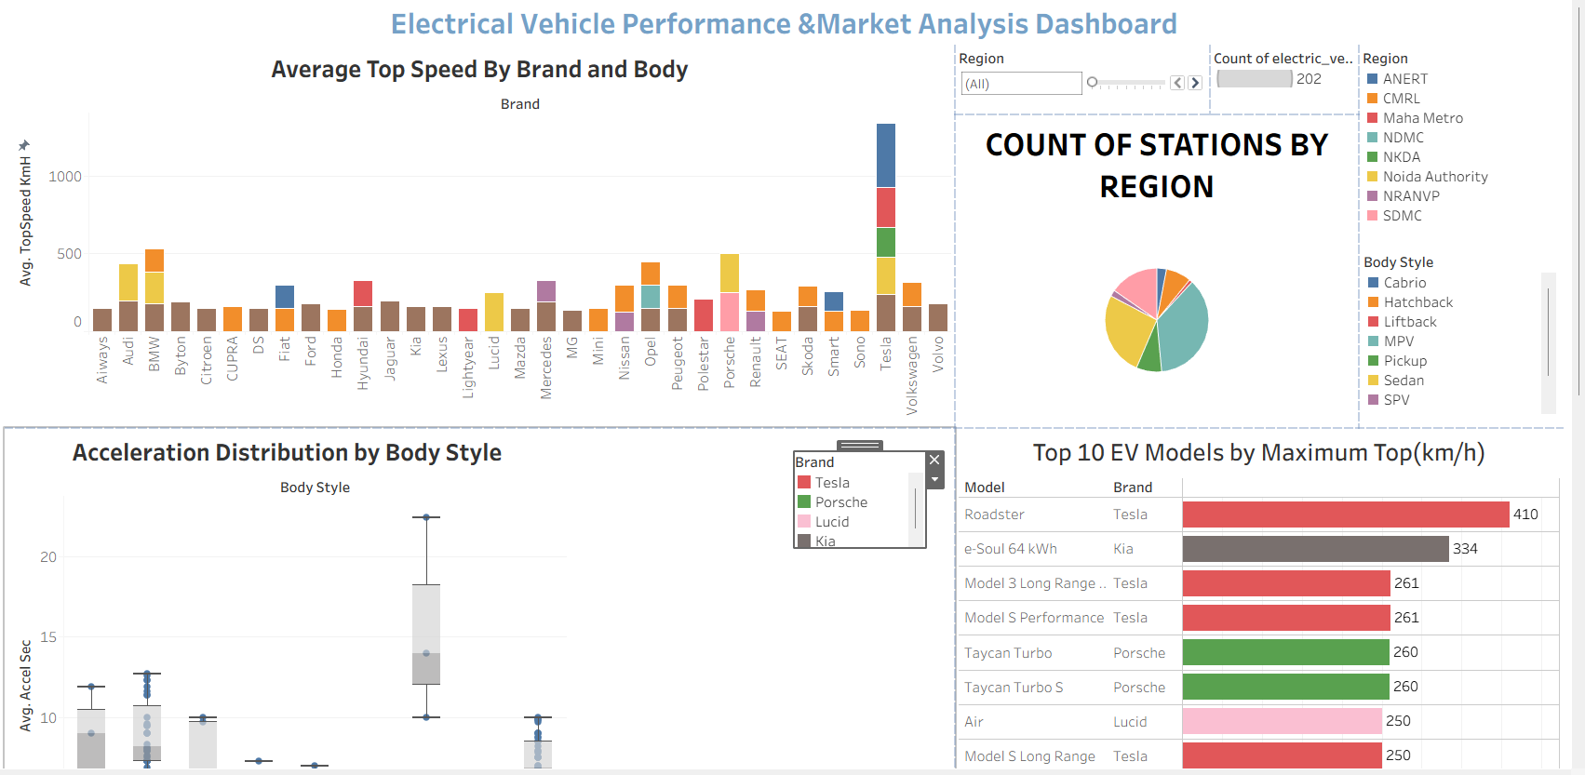

Figure 7.1 Final Interactive Dashboard

Page16

8. ADVANTAGES & DISADVANTAGES
The Electrical Vehicle Performance & Market Analysis Dashboard provides an interactive and data-driven platform for analyzing electric vehicle performance, pricing, charging infrastructure, and market trends. While the project offers several advantages in terms of visualization and decision-making, it also has certain limitations that can be addressed in future enhancements.

8.1 Advantages
1. Interactive Dashboard
The Tableau dashboard provides an interactive interface that allows users to explore electric vehicle data using filters, tooltips, and dynamic visualizations. Users can easily compare different EV brands, models, and specifications.

2. Improved Decision-Making
The dashboard transforms raw EV data into meaningful business insights, enabling customers, researchers, and analysts to make informed decisions regarding vehicle performance, pricing, and charging infrastructure.

3. Effective Data Cleaning
The project utilizes MySQL to preprocess raw datasets by:
- Handling missing values.
- Removing duplicate records.
- Converting text-based numerical values into numeric data types.
- Standardizing data formats.
This improves the reliability and accuracy of the analysis.

4. Comprehensive Performance Analysis
The dashboard enables users to compare electric vehicles based on:
- Top Speed
- Driving Range
- Acceleration
- Charging Speed
- Price
- Body Style
This provides a complete view of vehicle performance.

5. Charging Infrastructure Insights
The dashboard visualizes charging station distribution across different regions, helping users and planners understand infrastructure availability and identify areas requiring additional charging facilities.

6. User-Friendly Interface
The dashboard is designed with clear visualizations, interactive filters, and informative charts, making it easy for users with varying levels of technical expertise to interpret the data.

7. Supports Business Intelligence
The project demonstrates how business intelligence tools such as Tableau can transform raw data into actionable insights, supporting market analysis, strategic planning, and performance evaluation.

8. Scalable Design
The solution can be extended by integrating additional EV datasets, charging station data, and real-time information without requiring significant architectural changes.

8.2 Disadvantages
1. Static Dataset
The current analysis is based on historical datasets and does not include live or real-time electric vehicle information.

2. Limited Dataset Coverage
The dashboard analyzes only the datasets included in the project. It may not represent all EV models or charging stations available worldwide.

3. No Predictive Analytics
The project focuses on descriptive analytics and does not include predictive models for battery performance, future demand, or charging requirements.

4. Dependency on Data Quality
The accuracy of dashboard insights depends on the completeness and correctness of the source datasets. Inaccurate or incomplete data may affect the results.

5. Internet Requirement
Since the dashboard is published using Tableau Public, users require an internet connection to access the published version.

6. Limited Geographic Analysis
Charging station analysis is restricted to the available dataset and does not include global real-time charging infrastructure.

7. No User Authentication
The dashboard does not implement user authentication or role-based access control because it is intended for public analytical visualization.

8. Limited Mobile Optimization
Although the dashboard is accessible on mobile devices, the layout is primarily optimized for desktop viewing, and smaller screens may not provide the best user experience.

8.3 Summary
The Electrical Vehicle Performance & Market Analysis Dashboard successfully demonstrates the application of SQL data preprocessing and Tableau visualization for analyzing electric vehicle performance and market trends. Despite certain limitations such as the use of static datasets and the absence of predictive analytics, the project provides an effective analytical platform that supports data-driven decision-making.
The modular architecture and interactive dashboard design make the project scalable and suitable for future enhancements, including real-time data integration, advanced analytics, and machine learning-based predictions.

9. CONCLUSION

The Electrical Vehicle Performance & Market Analysis Dashboard was successfully developed to analyze electric vehicle performance, pricing, driving range, charging infrastructure, and market trends using MySQL and Tableau Public. The project demonstrates how raw and unstructured datasets can be transformed into meaningful business insights through data preprocessing, visualization, and interactive analytics.
During the project, multiple electric vehicle datasets were collected and integrated into MySQL. Various data preprocessing techniques were applied, including handling missing values, removing duplicate records, converting text-based numerical values into appropriate numeric data types, standardizing inconsistent data, and creating calculated fields. These preprocessing steps improved the quality and reliability of the dataset, ensuring accurate analysis and visualization.
The processed data was connected to Tableau Public, where several interactive dashboards and stories were developed. The dashboard presents key insights into electric vehicle performance through visualizations such as average top speed by brand and body style, charging station distribution by region, top-performing EV models, acceleration analysis, price comparison, and average driving range. Interactive filters enable users to explore the data from multiple perspectives and compare vehicles based on their requirements.
The project successfully achieved its primary objectives of transforming complex datasets into an easy-to-understand analytical platform. The dashboard provides valuable insights for EV buyers, business analysts, researchers, automobile manufacturers, and policymakers by supporting informed, data-driven decision-making.
Overall, this project demonstrates the practical application of SQL, data preprocessing, and Tableau visualization in solving a real-world business problem. It highlights the importance of clean data, effective visualization, and interactive dashboards in extracting actionable insights from large datasets. The developed solution is scalable and can serve as a foundation for future enhancements, including real-time data integration, predictive analytics, and machine learning-based electric vehicle analysis.

9.1 Key Achievements
The major achievements of this project include:
- Successfully integrated multiple electric vehicle datasets into a centralized MySQL database.
- Performed comprehensive data cleaning and preprocessing to improve data quality.
- Removed duplicate records and handled missing values effectively.
- Converted text-based numerical values into appropriate numeric formats.
- Developed multiple interactive Tableau visualizations for EV performance analysis.
- Created an integrated dashboard with dynamic filters and interactive features.
- Designed a Tableau Story to present analytical insights in a logical sequence.
- Generated meaningful business insights to support electric vehicle market analysis and decision-making.

9.2 Project Outcome
The completed dashboard provides a centralized platform for analyzing electric vehicle performance and market characteristics. It simplifies the comparison of different EV models and enables users to evaluate important parameters such as performance, pricing, charging speed, and driving range through an intuitive and interactive interface.
The project demonstrates how business intelligence tools can be effectively applied to real-world datasets to improve analytical capabilities and support evidence-based decision-making.

10. FUTURE SCOPE

The Electrical Vehicle Performance & Market Analysis Dashboard establishes a strong foundation for analyzing electric vehicle performance and market trends using SQL and Tableau. Although the current implementation provides valuable insights through data preprocessing and interactive visualizations, several enhancements can further improve the system's capabilities and expand its practical applications.

10.1 Real-Time Data Integration
The current dashboard uses static datasets for analysis. In the future, the system can be enhanced by integrating real-time data from electric vehicle manufacturers, charging station networks, and government open-data platforms through APIs. This would provide users with up-to-date information on vehicle specifications, charging station availability, and market trends.

10.2 Machine Learning-Based Predictions
Machine learning techniques can be incorporated to provide predictive insights, including:
- Electric vehicle price prediction.
- Driving range estimation based on battery specifications.
- Charging time prediction.
- Market demand forecasting.
- Battery degradation and performance prediction.
These predictive capabilities would help users make more informed decisions.

10.3 Live Charging Station Analysis
The dashboard can be connected to live charging station APIs to display:
- Real-time charger availability.
- Charger status (Available/Occupied).
- Waiting time estimation.
- Charging station utilization.
- Route-based charging recommendations.
This feature would significantly improve the usefulness of the dashboard for EV users.

10.4 Geographic Information System (GIS) Integration
Integrating GIS and interactive maps would enable users to visualize:
- Charging station locations.
- Regional EV adoption.
- State-wise charging infrastructure.
- Distance between charging stations.
- High-demand EV regions.
This would enhance spatial analysis and support infrastructure planning.

10.5 Advanced Business Intelligence Features
Additional business intelligence capabilities may include:
- Market share analysis by manufacturer.
- Sales trend analysis.
- Brand performance comparison.
- Customer preference analysis.
- Profitability analysis for EV manufacturers.
These features would provide deeper insights for businesses and researchers.

10.6 Mobile and Web Deployment
The dashboard can be deployed as a responsive web application or mobile application, allowing users to access EV analytics from any device with an internet connection. This would improve accessibility and user experience.

10.7 User Authentication and Role-Based Access
Future versions can include secure user authentication and role-based access control, enabling customized dashboards for:
- Customers
- Business Analysts
- Researchers
- Automobile Manufacturers
- Government Agencies
This would improve security and provide personalized analytical experiences.

10.8 Automated Reporting
The system can be enhanced to automatically generate and distribute reports in PDF or Excel format on a scheduled basis. This would help organizations monitor EV market trends without manual intervention.

10.9 Integration with IoT and Smart Vehicles
The dashboard can be integrated with IoT-enabled electric vehicles to collect real-time operational data such as:
- Battery health
- Energy consumption
- Vehicle diagnostics
- Charging status
- Driving patterns
This would enable continuous monitoring and more advanced performance analysis.

10.10 Cloud-Based Analytics Platform
Migrating the project to a cloud platform would improve scalability and accessibility. Cloud deployment would support:
- Centralized data storage
- Multi-user access
- Automatic data synchronization
- Remote dashboard access
- Scalable analytics for larger datasets

Summary
The proposed future enhancements will transform the current dashboard into a comprehensive electric vehicle analytics platform capable of supporting real-time monitoring, predictive analytics, intelligent decision-making, and large-scale market analysis. By integrating advanced technologies such as Machine Learning, IoT, GIS, Cloud Computing, and Real-Time APIs, the project can evolve into a powerful business intelligence solution for electric vehicle manufacturers, researchers, policymakers, and consumers.

11. REFERENCES (Recommended to include after Future Scope)
Include references such as:
- Tableau Public Documentation – https://public.tableau.com/
- MySQL 8.0 Documentation – https://dev.mysql.com/doc/

12. APPENDIX
Include:
- DashboardData Cleaning Screenshots
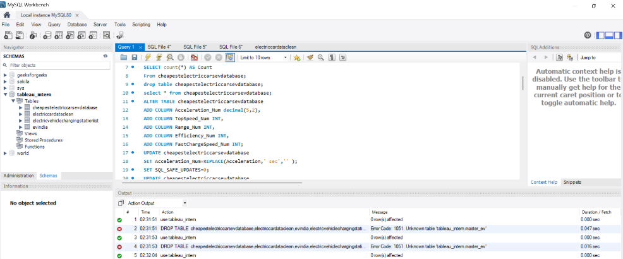

Dashboard Screenshots
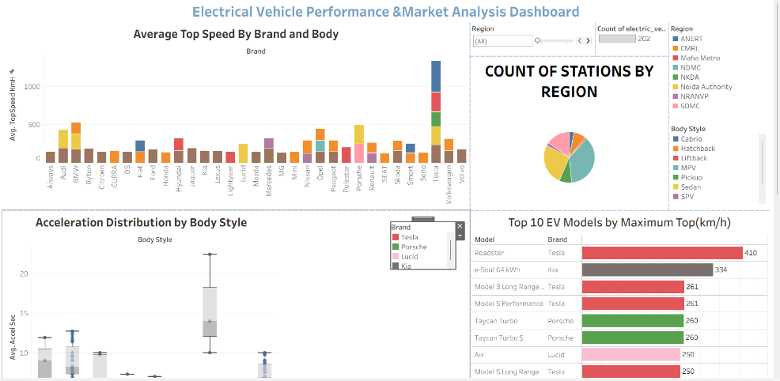

Tableau Story Screenshots :
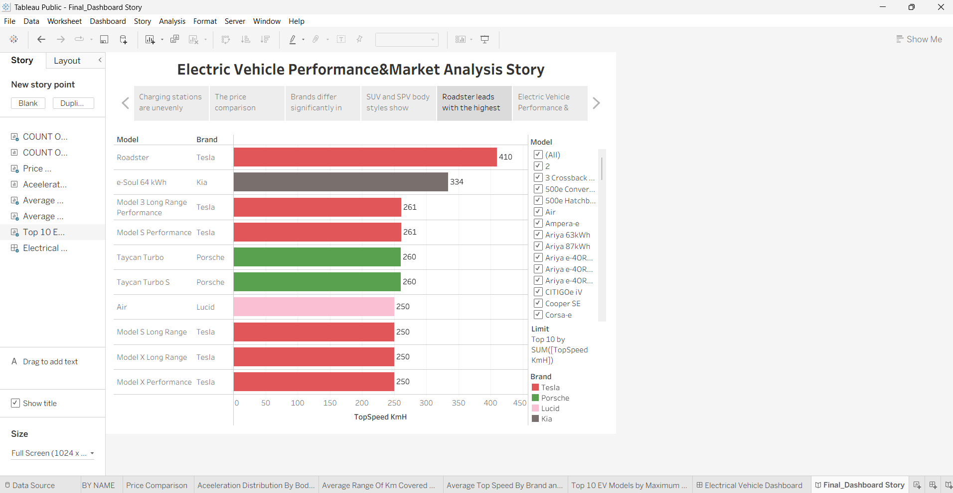
GitHub Repository Link (if available) -GitHub
- Tableau Public Dashboard Link- Final_Dashboard

